***Project Plan***

**<Project Overview>**

Project ID: SOI-****-****-****

Project Title: Implementation of Security Infrastructure on the Cloud

Skills Required:

1. AWS Cloud Services: - EC2 Instances - S3 Buckets - EBS Volumes - KMS -IAM - VPC - Route 53 - RDS - Security Hub - etc.

2. Networking

3. AWS CLI

Project Details:

Students are required to design and deploy cloud infrastructure to achieve similarities to traditional 3 tier web applications i.e. web tier, application tier, and database tier. Students will be working using AWS cloud. Auto-scaling and security of the application are important deployment factors.

Deliverables:

a) Deploy a Virtual Private Cloud (VPC);

b) Design and deploy a 2 tiers architecture on Cloud (Web-App Tier and DB Tier);

c) Web-App tier uses apache web server and PHP application while Database tier uses MySQL. Use XAMPP software for the various tiers.

d) Encrypt data in transit (using HTTPS) and data at rest;

e) Set up the necessary security groups and IAM groups/users/roles;

f) Deploy auto-scaling for Web-App tier;

g) Develop a simple web service where read and write to the database are applicable;

h) Backup and restoration of MySQL database using manual snapshot for Elastic Block Store (EBS); Store the EBS snapshot on AWS Simple Storage Service (S3).

i) Use AWS CloudTrail to monitor activities in the VPC.

j) Use AWS Security Hub to secure the cloud infrastructure.

**<End of Project Overview>**

**Planning**

In the first 3 weeks of the FYP timeline it would be used for planning therefore the project plan within this time period is subject to a lot of change

Use Gantt Chart to properly plan out what needs to be done within a set amount of time

The tasks that need to be completed would be stated in this project plan

**Design**

Use Xampp as a base of Web Service (Contain Apache & Database) → To be implemented in the AWS instances → Transfer the source code

Possible website ideas: education/shoe/t-shirt/books/portfolio

**Finalized website idea:** Online bookshop

Website main page view: (Draft)



After searching

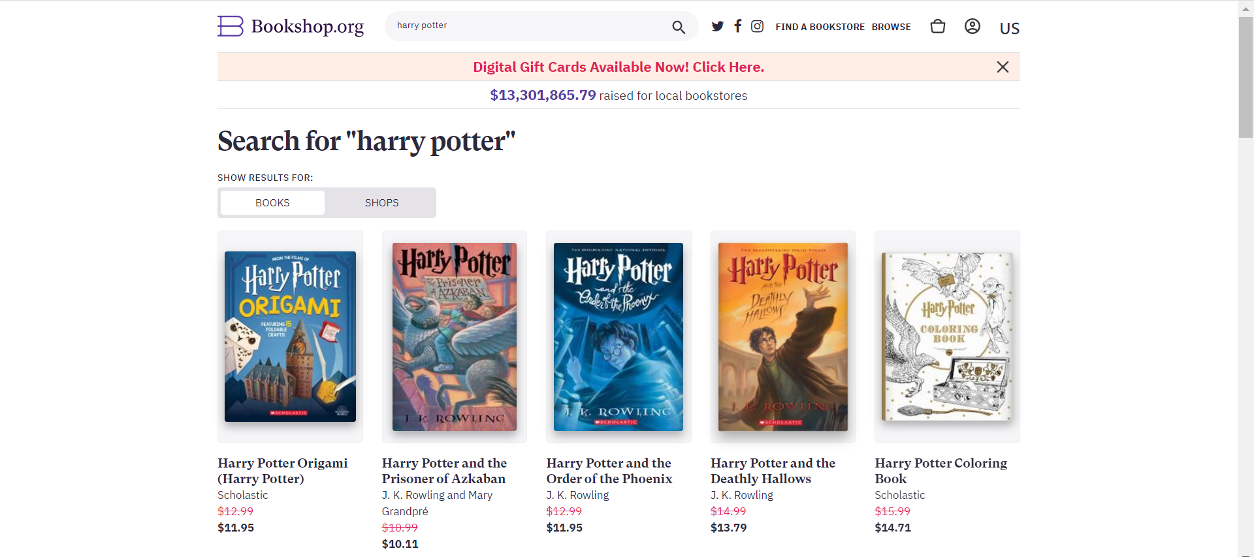

Website

1. Login page  
   → Users would enter their login credentials

→ Having the admin functions (TBD)

1. Listing page  
   → Display all the book available & price & rating

→ For pictures save it into the one folder and target it from there   
→ (search bar - TBD)  
→ List the inventory available smallest number has to be 0

1. Add to cart features

→ Quantity left   
→ book cost   
→ total cost bottom of the page   
→ Payment type (nets, Mastercard, etc.)  
→ Have some sort of validation should not have values that are out of reality

1. Checkout page  
   → Payment is not of concern
2. Registration page

**Implementation**

* After designing the website implementation inside the AWS would happen to secure it.
* Require puTTY
* Setting up the instance is something that we have done before however make sure SSH and HTTP
* SSH into instance when instance is deployed
* Ensure apache is installed.

**Implementation**

Configuration on the AWS

→ High availability (Lesson 6)

→ Load Balancing (2 Web Servers) (Lesson 7)

→ Data Security (Lesson 8 & 9)

→ Permissions in Group, user policies (Lesson 10)

→ VPC, NAT Gateway (Lesson 12)

**Testing**

After successful implementation

→ Test link

→ Ensure there are no vulnerabilities (e.g. burp suite)

**Documentation**

* Would be done every time the team meets to complete our work.
* Document for documentation would be up on google docs so as any team member can change and add details other than during the meeting day.
* Documentation should provide important details and milestones that would be shared with the supervisor in the progress meetings.